**Screenshots of webpages in the application**

**Login Page :**

**Here is the login page after clicking on signup if login is successful it will redirect to the home page**

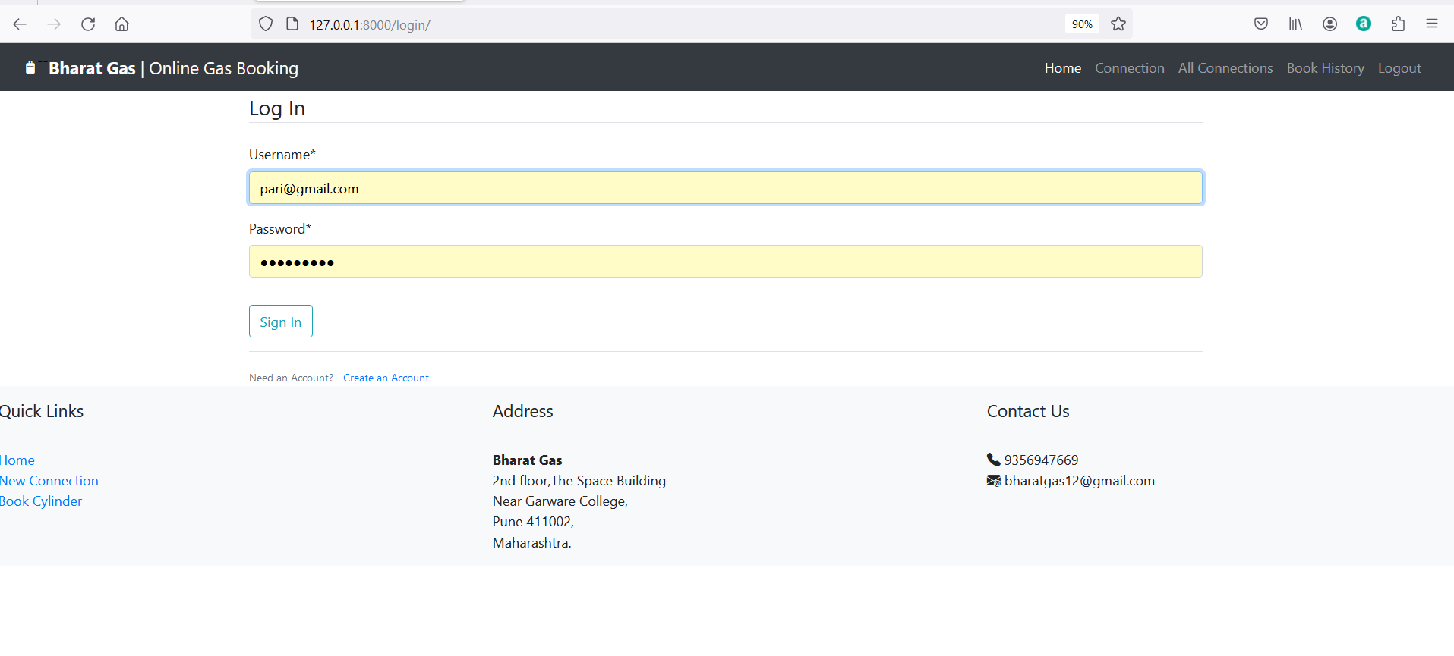

**Register page :**

**For login you have to register first . after clicking on creat an account it will redirect to the register page**

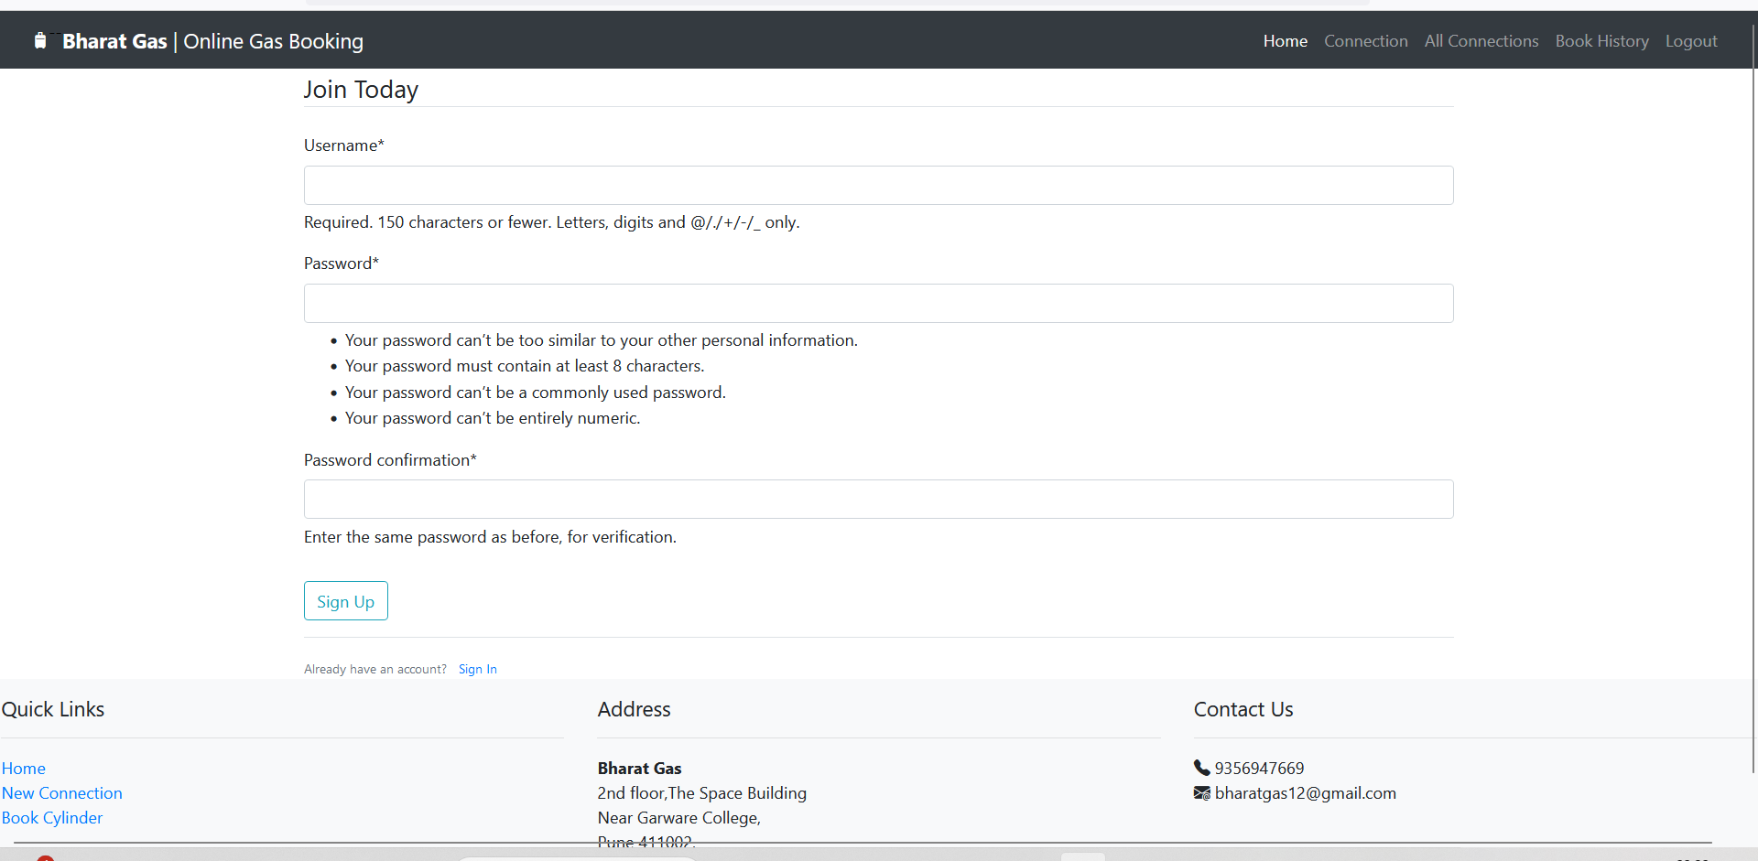

**Home Page :**

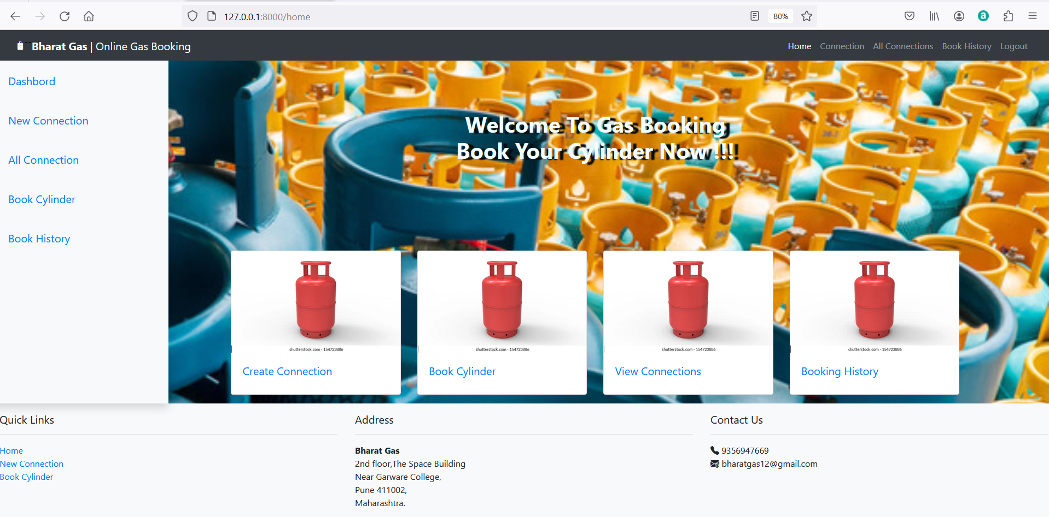

**Connection Page :**

**When you click on connection it redirects to the connection page to create new connection.**

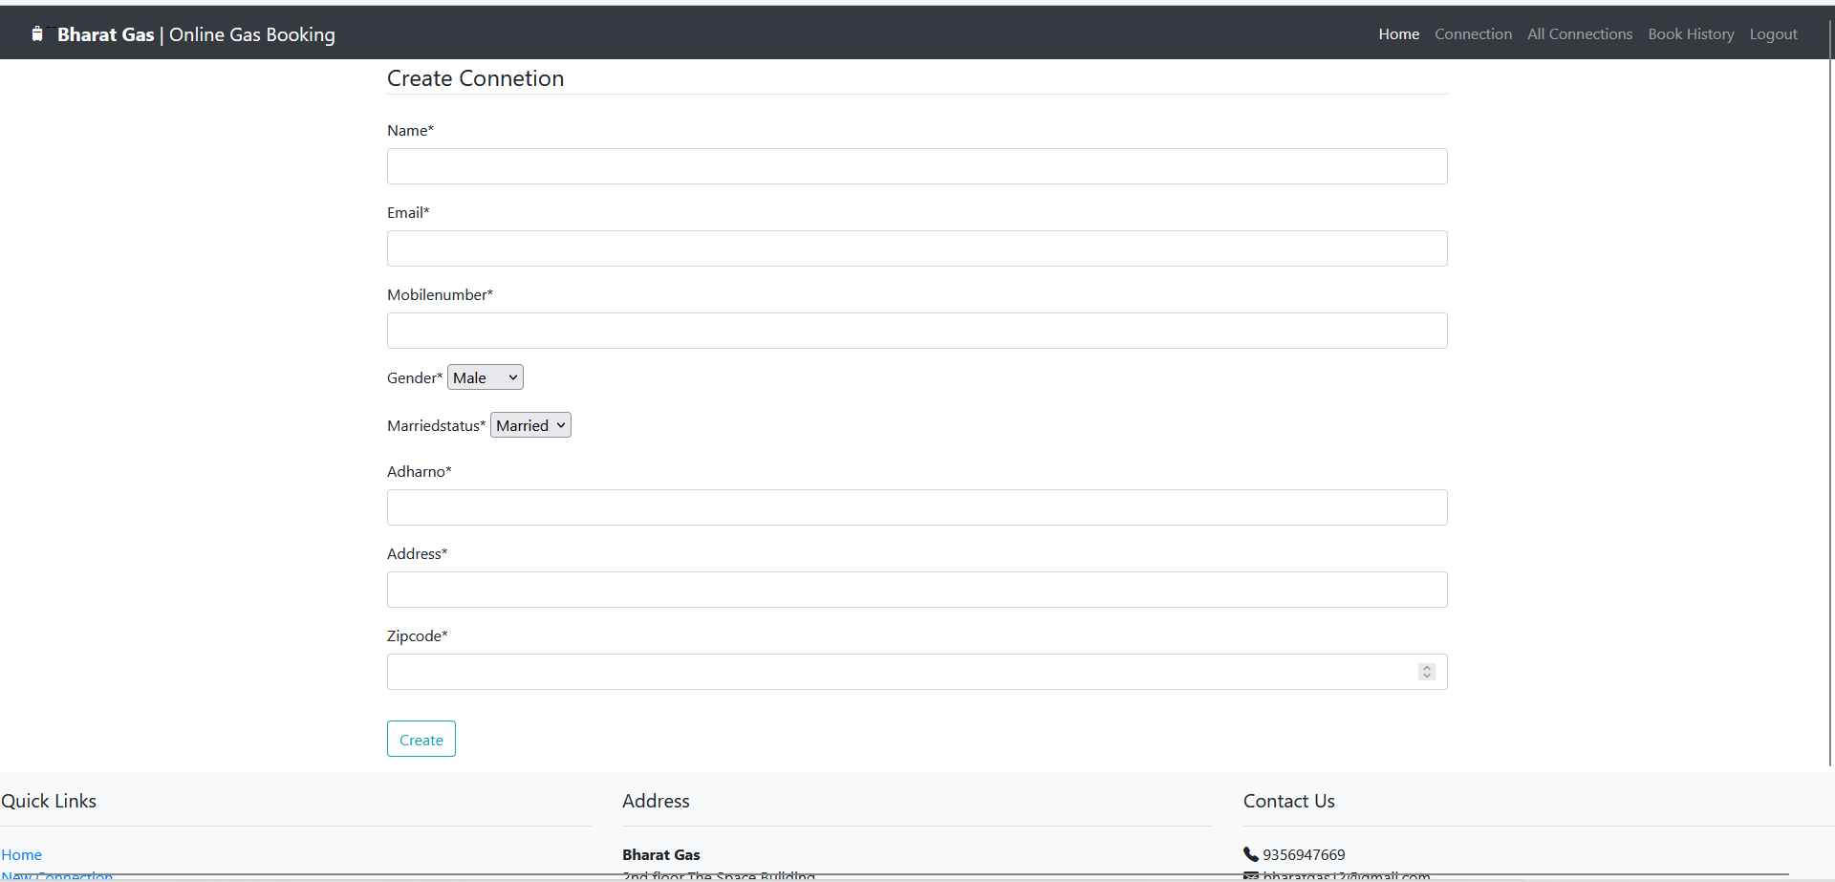

**All Connection page :**

**When you click on all connections it will display all the connections . the delete and update functionality are available for that connection you can delete the connection and also update the connection info.**

**And book cylinder for that connection . after clicking on book cylinder it will redirect to the book cylinder page.**

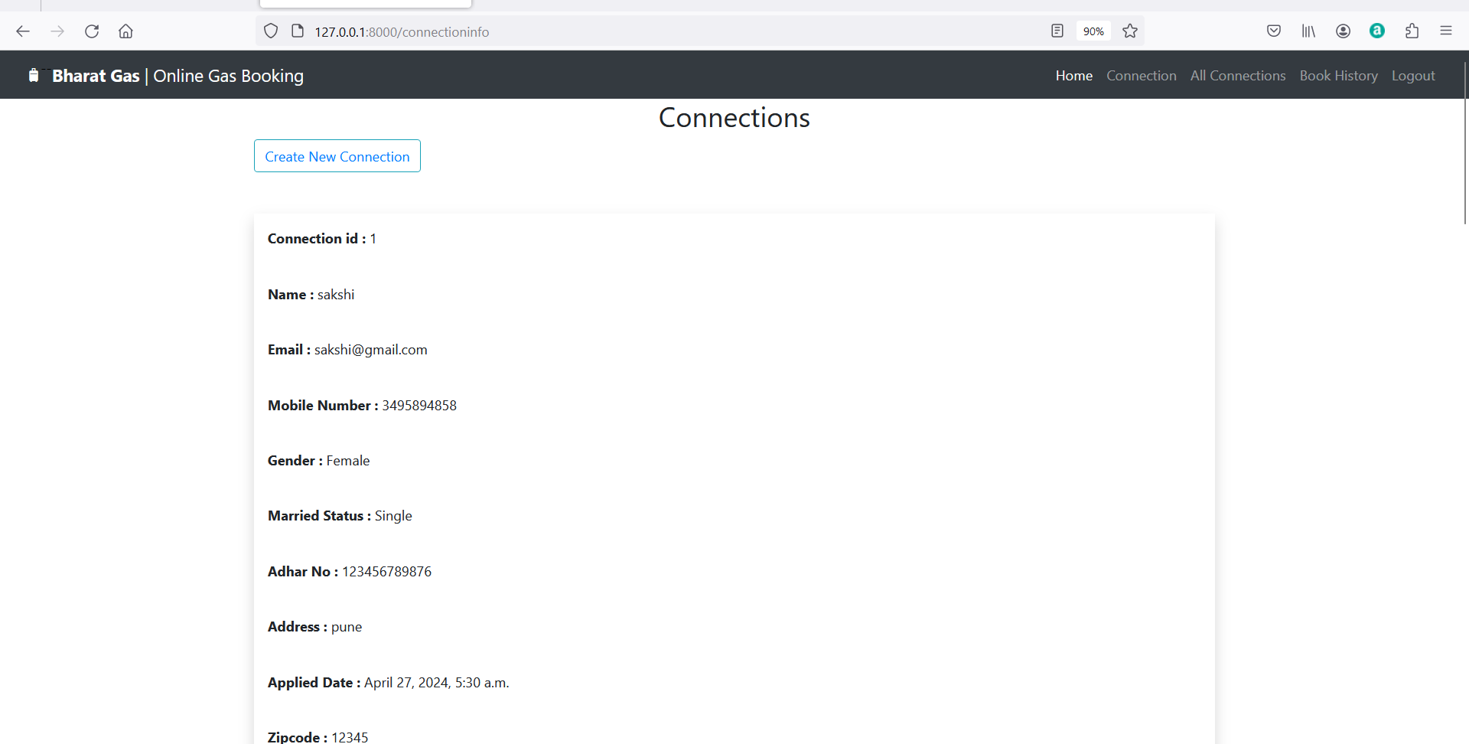



**Book cylinder page :**

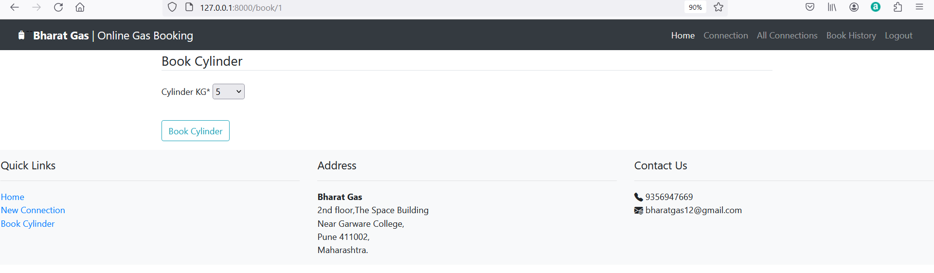

**Booking History :**

**After cylinder booking . it will display the details of connection and cylinder in bookhistory. Here the status will be updated on table as per it will updated by the admin**

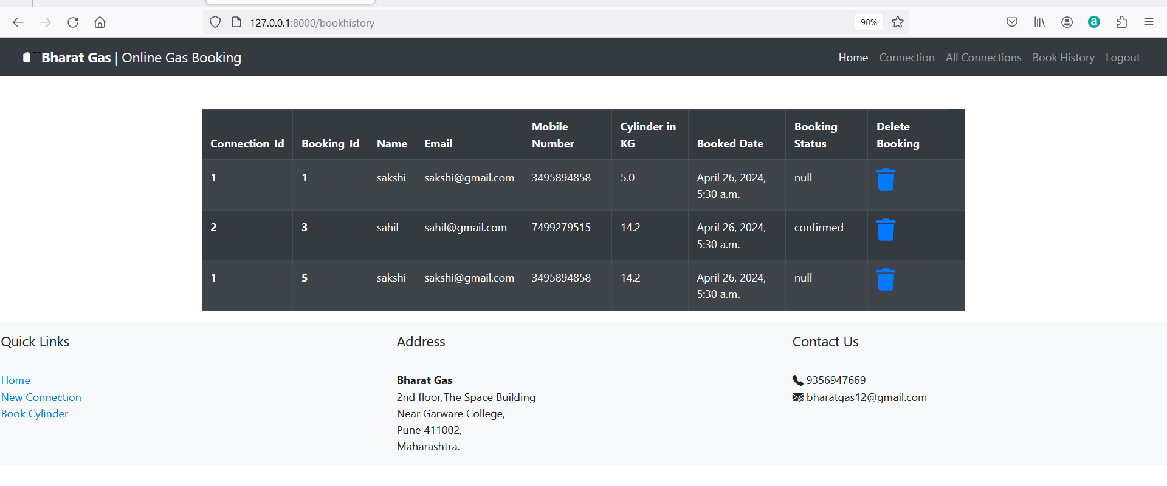

**And after clicking on logout you will redirect to the login page.**